WTO’s Innovative New “QuickFlex®” System
Saves Money Up Front—and Over Time.
The perfect combination: ER collet chuck and quick change system in one toolholder.

Charlotte, NC (August 2013)—In the past, acquiring non-perishable tooling after a major machine purchase required a large expenditure—one that was often uncomfortable for companies with limited budgets. In today’s hyper-competitive marketplace (especially in the middle of a still-sluggish economy), this cash outlay can be worse than uncomfortable: It can be crippling. That’s why, for leaders focused on conserving costs and improving productivity, WTO’s innovative new system can be a game-changer.
QuickFlex®, a new and innovative quick change system for driven toolholders, saves a substantial amount of money in out-of-pocket tooling costs. Plus, it dramatically reduces tool change time and provides greater flexibility.
“Providing an ER collet chuck and quick change system in one toolholder allows you to buy many fewer tools than you would have to otherwise,” says Anthony DeHart, director of sales and business development at WTO USA. “Best of all, this flexible system doesn’t compromise rigidity, performance, or accuracy, which is great news for high-precision contract manufacturers.”
QuickFlex® was officially introduced in 2012 and is now available for the North American market. It offers a complete toolholder program for the most popular turning center models using bolt-on turrets.
Specifically, DeHart says, the QuickFlex®’s base unit allows customers to clamp tools directly into the ER collet of the toolholder—no additional purchases necessary. If customers acquire additional types of tooling in the future, they can be easily accommodated by using the QuickFlex® adapters, which are mounted directly into the base unit.
“The base unit comes in a straight (radial) or right angle (axial) configuration, which—combined with the wide range of adapters available—covers virtually any machining process requirement, all in a single system,” DeHart explains. “This approach enables the company to incrementally invest in a full range of options with minimal initial capital requirements. It also accommodates the multiple setups and frequent changeovers that are required for the short manufacturing runs in today’s production environment.”
Here, DeHart shares seven specific benefits of WTO’s QuickFlex® system:
QuickFlex® is comprehensive. The comprehensive QuickFlex® system covers a full range of different tool clamping adapter types and sizes. NOTE: SEE ATTACHED TIPSHEET FOR DETAILS.
The system is extremely cost effective. With a minimal initial investment, customers can get unprecedented mileage out of toolholders. You can start by simply clamping the cutting tools directly into the toolholder using a standard ER collet. You don’t have to buy a complete quick change system right off the bat.
Setup time is reduced. For all manufacturers, time is money. The longer it takes to change from one tool to another, the longer production is paused. Setup delays can seriously cut into productivity and limit profits. In contrast, QuickFlex®’s cutting tools can be preset while the machine is operating, meaning that the setup time for tool change at the machine can be significantly reduced.
QuickFlex® delivers precision and performance. WTO has always set the benchmarks for driven tool technology with its inventions. With QuickFlex®, the company is once again breaking ground as it combines precision with high rigidity and safe handling.
It incorporates user-friendly handling. Changing tools is quick and easy with WTO’s new one-hand wrench, which is patent registered. Just use the one-hand wrench to hold the QuickFlex® spindle, and tighten the large collet nut with the spanner wrench. The QuickFlex® adapters, which use the inbuilt thread nut, are tightened the same way.
It’s also surprisingly flexible. While the QuickFlex® toolholder can be used without a quick change system, it’s also easy to add a quick change function. If you buy quick change adapters after your initial purchase, you’ll reduce tool change time even more dramatically. The complete quick starter kit, which is user friendly and reasonably priced, includes three different adapters and a one-hand wrench set.
QuickFlex® improves tool change handling. In the past, changing tools has been difficult, time consuming, and in some cases risky. Not so with QuickFlex®. This system boasts quick, easy, and safe tool change handling with the new one-hand wrench.

“With QuickFlex®, our goal was to develop a compact, simple, and safe quick change system for driven toolholders,” Karlheinz Jansen, technical director and member of management, WTO GmbH, concludes. “High cutting performance and long life have always been the benchmark of our Performance Series. Now, we’ve made those high-quality products even better!”
# # #

Getting to Know the QuickFlex® System: A Visual Tour
These images will acquaint you with the QuickFlex® system and its most outstanding features.

The basic elements of the QuickFlex® system are the two independent taper connections (image 3). The short taper (image 2, detail 8), located closely behind the thread of the collet chuck, is for radial centering and axial support of the QuickFlex® adapter. This taper guarantees that the system will be highly precise, independent of possible abrasion at the cone of the ER collet chuck. The location of the taper behind the thread (image 2, detail 7) keeps it protected against chips and dirt, which permanently guarantees the high precision of the system.
The short taper also works as a defined contact face, whereas the rear part of the ER collet chuck cone guarantees backlash-free radial bending support of the QuickFlex® adapter (image 2, detail 11). Combined with the large thread (image 2, detail 7), these two taper connections lead to the high rigidity and stability of the system.
Additionally, the full performance can be transmitted from the turning center to the cutting tools. The polygonal torque transmission (image 2, detail 10) is placed just behind the radial support.

- QuickFlex® straight and right angle drill/milling unit with adapters and boring bar holders for flexible use of QuickFlex® adapters.

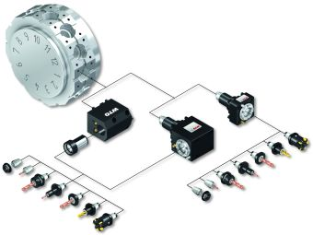
- The perfect combination: ER collet chuck and quick change system in one toolholder.
Parts include:
1 – Toolholder
2 – QuickFlex® chuck
3 – Collet
4 – Collet nut
5 – QuickFlex® adapter
6 – One-hand wrench (patent-registered)
7 – Thread for QuickFlex® adapter and collet nut
8 – Short taper for radial centering and axial support of the QuickFlex® adapter
9 – Taper of the ER collet chuck
10 – Polygonal torque transmission for QuickFlex® adapter
11 – Radial bending support of the QuickFlex® adapter for high stiffness under load

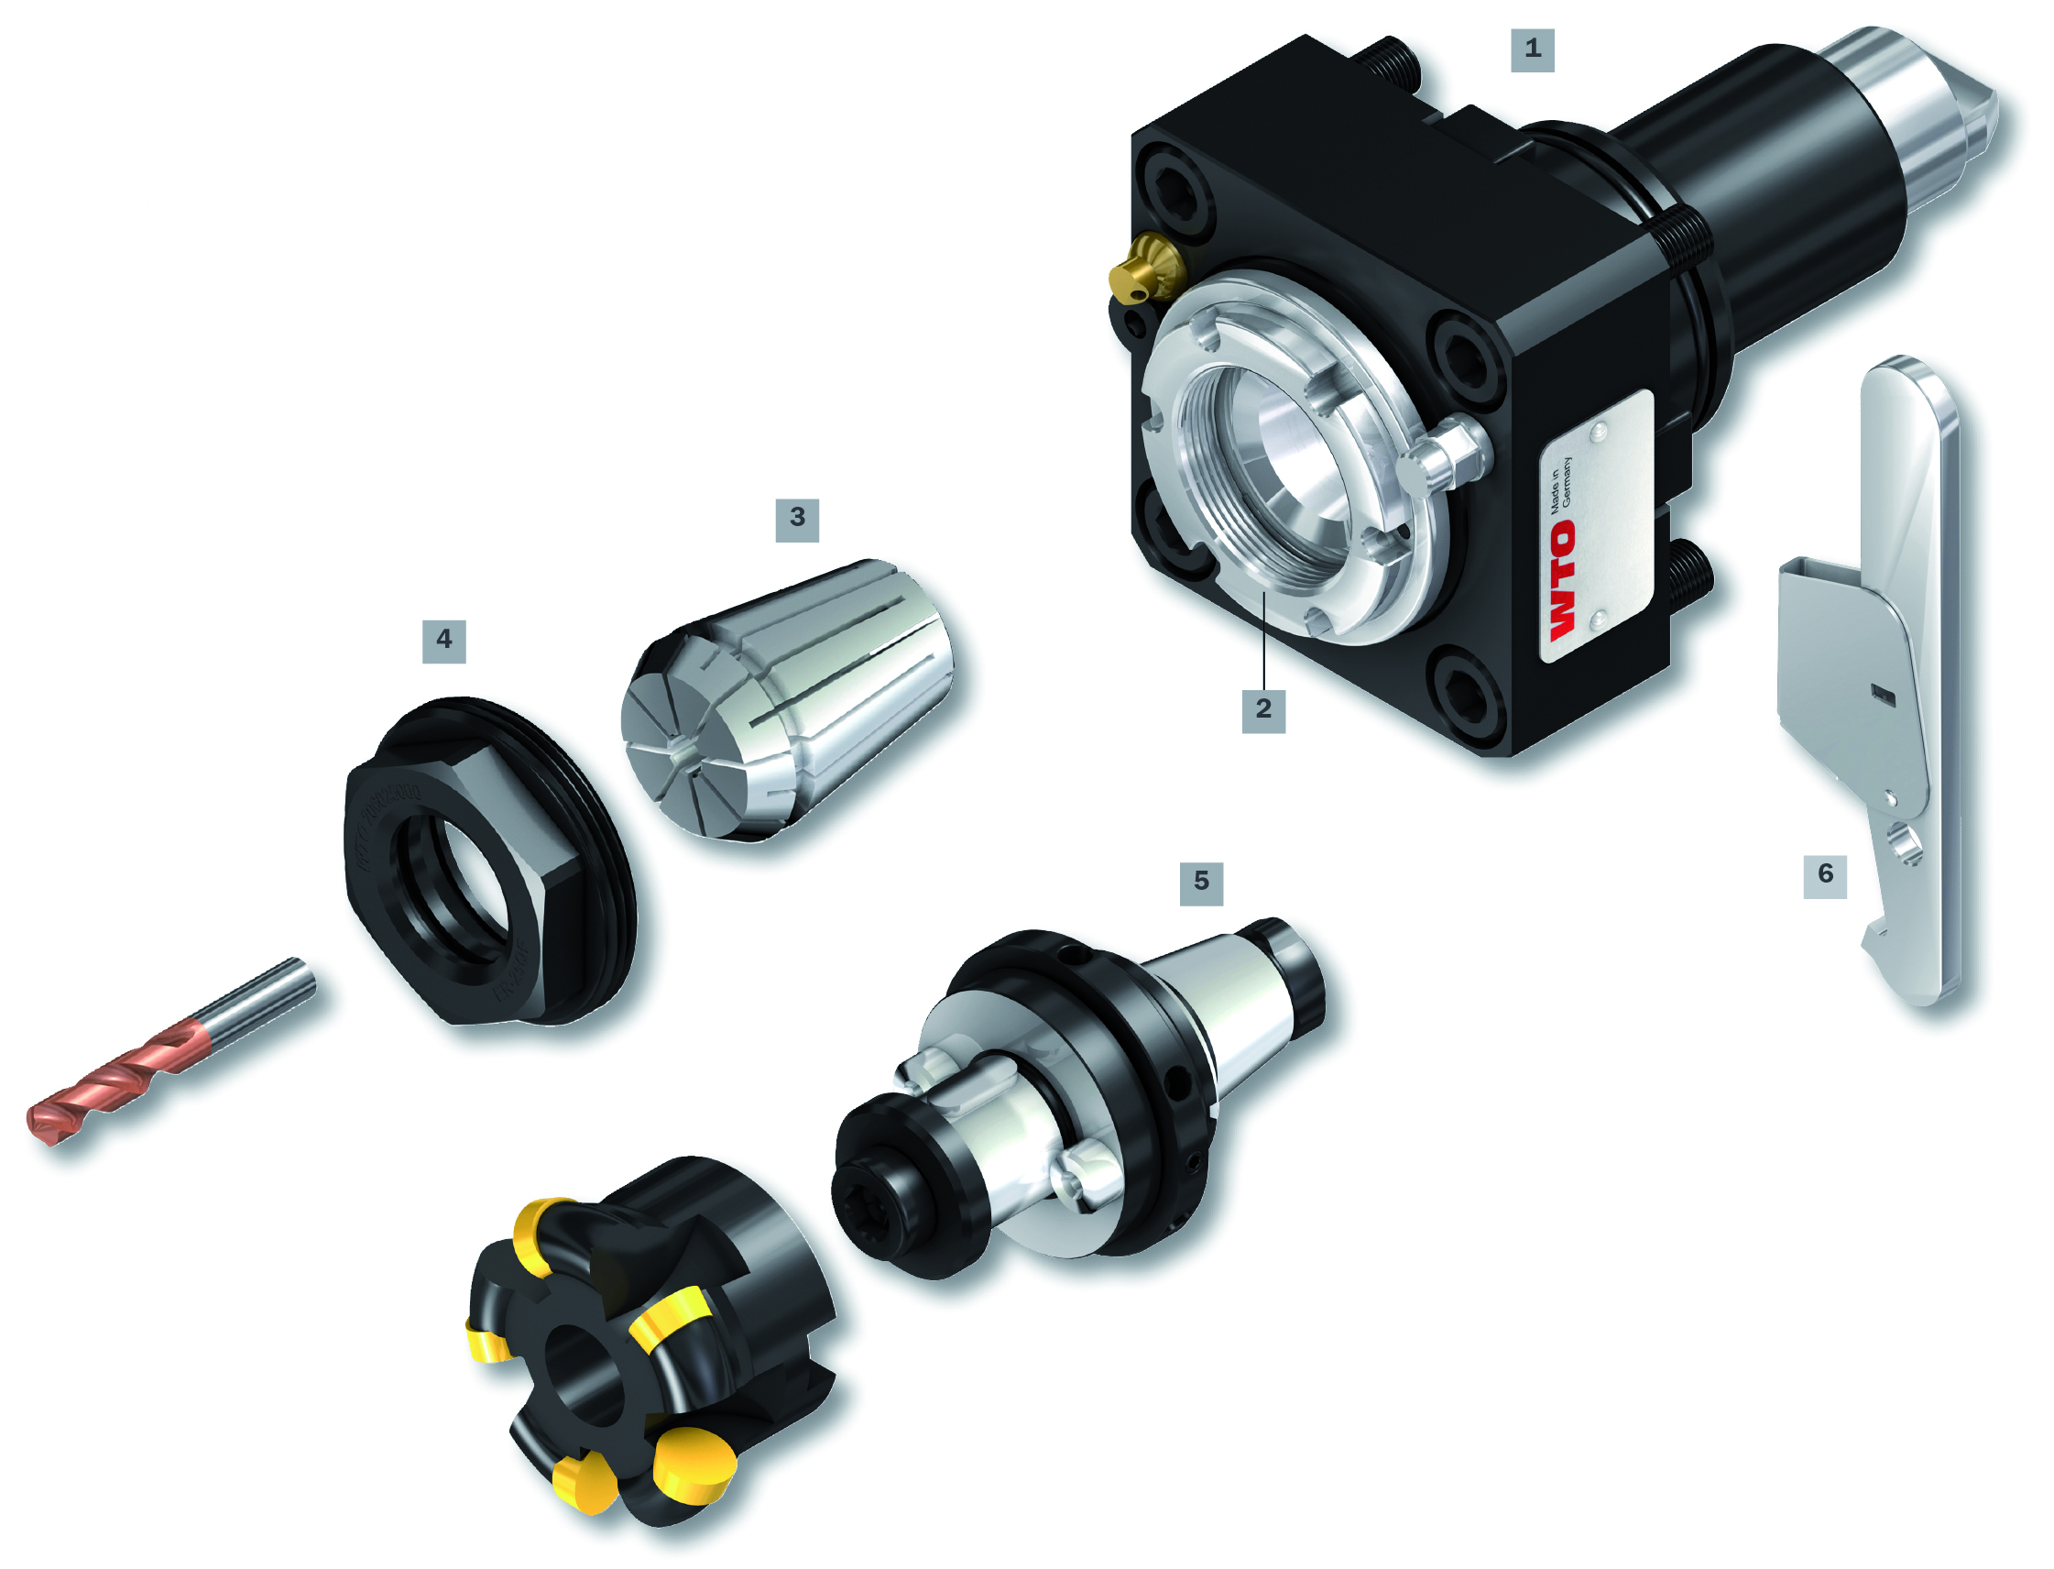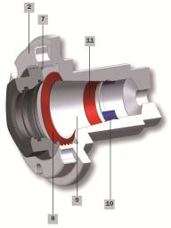

- Permanent accuracy of the run-out is guaranteed by two independent taper connections.
Left: with ER collet
Right: with QuickFlex® mill arbor adapter

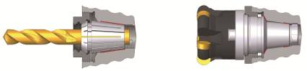

- Quick and safe tool change with the new one-hand wrench (patent-registered).

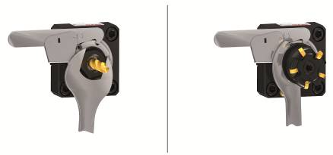

- Starter set with collet chuck adapter, Weldon/Whistle Notch adapter, short combination mill adapter, one-hand wrench, and spanner wrench.

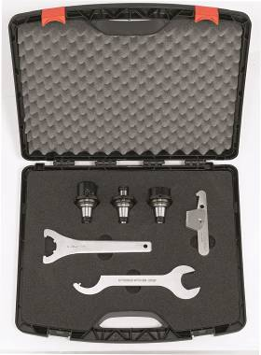

# # #

About WTO:
WTO has specialized in the design and manufacturing of high-precision toolholders for CNC Machine Tools since 1977. As a recognized pioneer and leader in its industry, WTO has always set the benchmarks of driven tool technology with its inventions and new developments.
Their products are known for achieving higher productivity and longer tool life with technically advanced design features and by being produced to extremely close tolerances under strict quality controls. WTO specializes in the production of static and driven toolholders for Multi-Task Machines, Turning Centers, Multiple Spindle Machines, and Swiss Type Machines. The products are used worldwide in the metal cutting industry anywhere high-precision parts are required to be manufactured with efficiency.

WTO’s strategy is to constantly strive for excellence in technology and to serve the market with exceptional service. To maintain high quality standards, all products are manufactured exclusively in Germany.

WTO is a privately held, family-owned enterprise, currently led by the second generation with headquarters located in Ohlsbach, Germany. The current management has maintained the company’s focus of driven toolholders thus ensuring a strategic comparative advantage within this market.

Offices in Charlotte, NC, are dedicated to providing the highest level of customer service and support for the North American markets. An in-house service center provides both preventative maintenance and complete rebuilds to exacting factory standards.

All WTO products are made in Germany and include:

- Precision static toolholders
- Precision driven toolholders/Performance Series®
- Precision driven toolholders/QuickFlex®
- Precision toolholders with Coromant Capto®
- Gear hobbing units
- Precision thread whirling units for Swiss Type turning centers
- Precision toolholders for multiple spindle turning centers

To learn more, please contact:
Anthony DeHart
Director of Sales and Business Development
Telephone: +1 828-217-3739
E-mail: anthony.dehart@wto-usa.com

WTO Inc.
14301-4 South Lakes Drive
Charlotte, NC 28273
USA
Telephone: +1 704-714-7765
Fax: +1 704-714-7767
www.wto-usa.com

